West Japan Model United Nations III
In-Person Manual
2022-2023

Welcome to the 3rd annual WJMUN conference. We hope this academic experience will serve to be fulfilling and engaging for your students. This handbook consists of information on how the in-person conference will be conducted.

Please refrain from distributing this handbook to those who are not involved with this event without the organizers’ consent.

Created by:
Marin Suzuki, WJMUN III, Main Organizer

Supported by:
Isa Jaro, WJMUN III, Secretary/Co-Organizer
Johan Barth, WJMUN III, Advertisement/Co-Organizer
Jiaxu Zhao, WJMUN III, Communications
Miyu Lee, WJMUN III, Communications
Alexander Kameoka, WJMUN III, Communications
Jiwon Lee, WJMUN III, Hosting
Souma Eguchi, WJMUN III, Hosting
Zhen Zhuo Li, WJMUN III, Finance
Shunsuke Endo, WJMUN III, Finance
Haruto Shimpo, WJMUN III, Technology

Table of Contents

Dates and Schedules

Venues

Roll Call

Lobbying Session

Seating Order

Speeches
Preambulatory Clauses, Operative Clauses

Motions/Points

Approval Processes

Amendment Procedures

Voting Procedures

Notes

Rules and Regulations

Requirements

Gossip Box

Dates and Procedures
Please note that the schedules are subject to change (lunctimes especially)

Friday, April 7th
JST | Event | Location
8:30 AM | Arrival in FIS | Fukuoka International School Annex
9:00 AM ~ 9:20 AM | Opening Ceremony | Respective Committee rooms
9:20 AM ~ 11:00 AM | First Session | Respective Committee rooms
11:00 AM ~ 11:15 AM | Break | On-Campus
11:15 AM ~ 12:30 PM | Second Session | Respective Committee rooms
12:30 PM ~ 1:30 PM | Lunch | Restaurants Provided by Tourism
1:30 PM ~ 4:00 PM | Third Session | Respective Committee rooms

Saturday, April 8th
JST | Event | Location
8:30 AM ~ 11:00 AM | First Session | Respective Committee Rooms
11:00 AM ~ 11:15 AM | Break | On-Campus
11:15 AM ~ 12:30 PM | Second Session | Respective Committee Rooms
12:30 PM ~ 1:30 PM | Lunch | Restaurants Provided by Tourism Department
1:30 PM ~ 4:00 PM | Third Session | Respective Committee Rooms

Sunday, April 9th
JST | Event | Location
8:30 AM ~ 10:45 AM | First Session | Respective Committee Rooms
10:45 AM ~ 11:00 AM | Break | On-Campus
11:00 AM ~ 1:30 PM | Second Session | Respective Committee Rooms
1:30 PM ~ 2:30 PM | Lunch | Restaurants provided by Tourism department
2:30 PM ~ 3:00 PM | Closing Ceremony | Fukuoka International School Gym

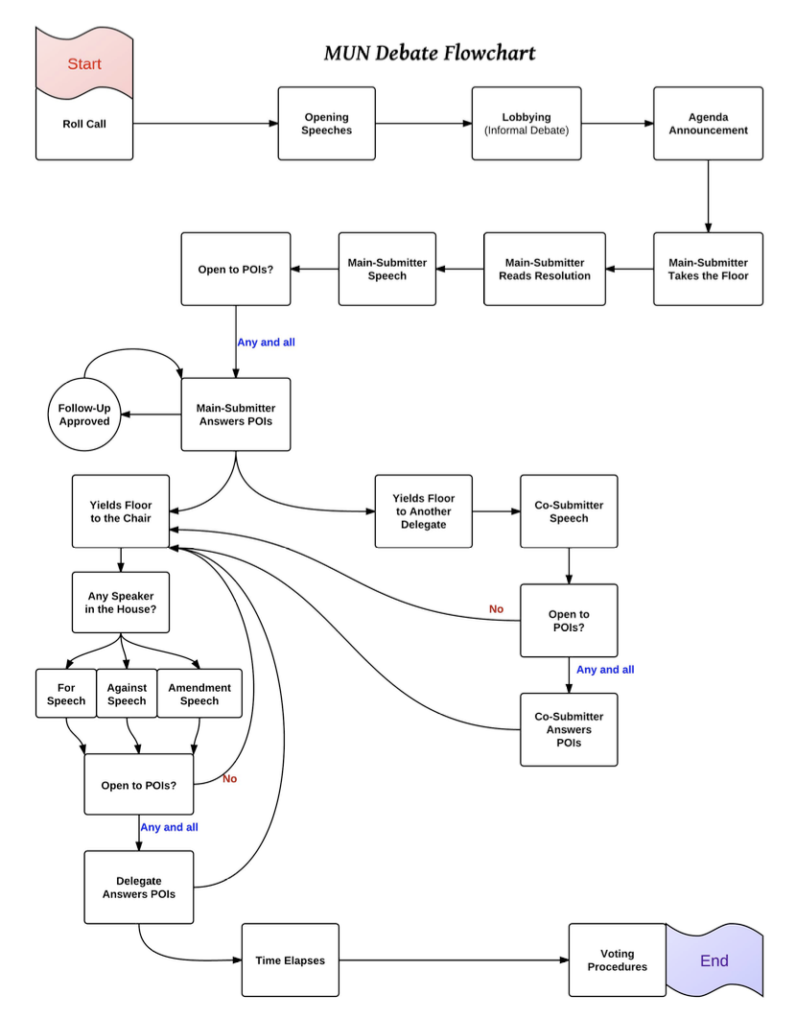

Committees
- United Nations Human Rights Council

- United Nations Security Council

- General Assembly

- World Health Organization

- Economic and Social Council

Roll Call:
The first session will begin with a call to order and roll call. When the chair calls the delegate’s country, the delegate will raise their placards and declare themselves as “present” or “present and voting”.

Present: The delegation is present and has the right to abstain on substantive matters.

Present and Voting: The delegation is present and will vote on all resolutions, the delegation does not reserve the right to abstain from voting.

Lobbying Session

Delegates will divide into groups based on their agendas. They will leave their seats and form a group with other delegates to work to compile and revise clauses into one whole resolution. Delegates must stay in the same room.

Reading Time
Delegates will have a reading time of 5 minutes for each resolution. Delegates are to use this time wisely to draft any speeches, amendments, etc.

Resolutions
On the second day of the conference, delegates will be given a physical copy of the resolutions that were approved on the first day. The resolutions will be shared via google drive on the night of the first day for any delegates who wish to prepare beforehand. There will also be a projector on for the entirety of the debate that presents the resolution in question.

Seating Order
The seating arrangement will be in alphabetical order of the nations.

Delegates will be assigned seats; delegates may not reorder their seating arrangement without the approval of the chair. When the delegates arrive, they must find their seats with their placards.

Speeches
When the delegate wishes to speak, they will raise their placards. When recognized they will stand in front of the podium (mic stand) and commence with their speeches. Once done they will return to their seats.

- Opening Speech: 45 seconds
- Main Submitter Speech: Once the operative clauses are read out, the main submitter has 3 minutes
- General Speeches: 90 seconds (may extend to 120 seconds if the delegate requests)

Language:
Delegates are reminded that First Person and Second Person pronouns are strictly prohibited in the debate
- I = This delegate
- Myself = The delegate himself/herself/themself
- You = The delegate of (the country you represent)
- They

Roll Call:
- Each delegate present in the conference is called by their country that they represent
- If present, they must reply with “present” or “present and voting” while raising their placards

Opening Speech:
Delegates are encouraged to write their opening speeches using the following outline:
- Hook
  - Question
  - Quote
  - Statistic
  - Story
- Point
- Call to action

Rules
- POIs are not accepted at this stage
- Delegate are given a 10 second warning when nearing the end of their time
  - If delegate exceeds 45 seconds, they will receive a warning by the chair

General Speech:
Making a basic statement
- It should be pointed out… / noted that… / mentioned that…
- The delegate from _____ would like to make it known that… / reveal… / reminds all delegates that…
- It seems that a strong resolution on this issue should… / there is a great deal of support for… / one of the main problems with this… is… / another option to… may be…

Against Speech:
When expressing opposition…
- Unfortunately, the delegate from ___ is unable to support / will have to reject / cannot offer their support to this resolution/clause because…
- The delegate of ___ is in favor of… but disagrees with …
- The delegation of ___ is alarmed by… / would like to express opposition to… / cannot agree with…

Points of Information (POI):
When asking a direct question
- The delegate from ___ would like to know how this resolution will stop… / prevent… / encourage… / discourage…
- Could the delegate from ___ please explain why… / how… / what the point of… is / the purpose of…
- The delegate of ___ would like to know why the delegate from ___ thinks… / assumes… / doesn’t think… / hasn't said anything about…
Rules:
- POIs are to be asked through the chair, not directly to the delegate
- Delegates are reminded to keep their POIs short and concise
- If the POI is not understood, the chair will ask the delegate to restate their POI
- Follow-ups are permitted as long as the question is relevant to the speech, not to the answer that the delegate gave in the first POI
  - POIs to the 3rd degree are to be declined

Preambulatory Clauses, Operative Clauses, and Sub-Clauses

Preambulatory Clauses
- Listed at the very beginning of the resolution
- Used to cite past resolutions, precedents, and statements about the purpose of action
- Should be used to define resolutions in the making
- Should not be clauses that take action
- Ends with a comma (,)
- Should start with any of the following phrases:
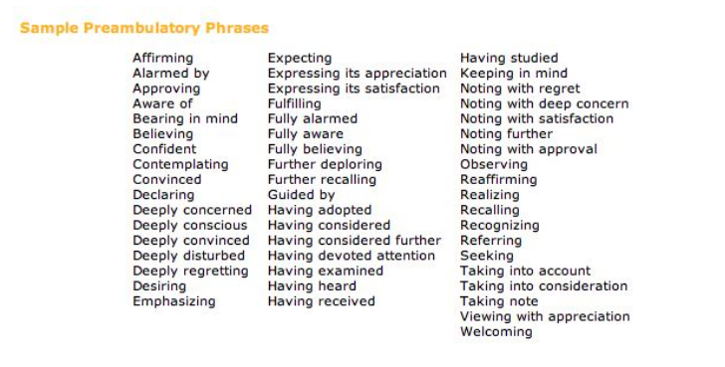

Operative Clauses
- Should be the majority of the resolution
- Used to propose actions that need to be taken for the issue being discussed
- Ends with a semicolon (;)
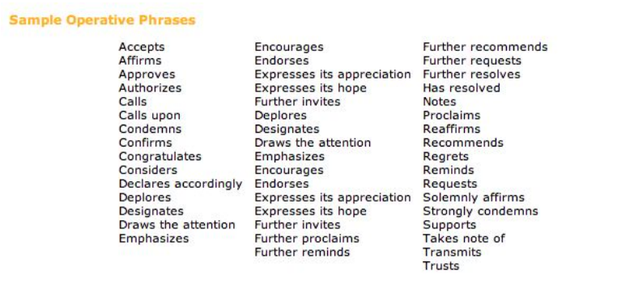
- Start with verbs such as:

Sub-Clauses:
- Clauses that are underneath operative clauses
- Usually used to provide examples of the action that is proposed
- Acts as modifiers to the operative clauses
- Also known as the dependent clause
- There must be two sub-clauses to prevent making it a hanging clause
- Sub-clauses to the third degree are not accepted
Rules for Formatting:
- Preambulatory clauses are not numbered
  - The opener of each preambulatory clause is italicized
- The opener of each operative clause is underlined
- Operative clauses are numbered in Arabic numerals (1., 2., 3., etc.)
- Subclauses begin with lowercase English alphabets (a., b., c., etc.)
  - Sub-sub-clauses begin with lowercase Roman numerals (i., ii., iii., etc.)
General Rules
- Resolutions should not exceed 4 pages (two pages double-sided).
- Submit all resolutions in Times New Roman, 11-point font.
- Nothing should be bold or colored.
- Do NOT number lines or pages.
- Single-spaced, with 1 line between each clause.

Special Committee Rules:
Committee: Security Council

- Debates per clause
- P5 nations each have veto power when voting for a clause
- P5 nations are granted a 2-minute caucus before voting procedures on a clause
- Voting and Amendment procedures stay the same
- SC, and HSC: 9 votes, with veto power of P5 nations
  - A veto must immediately be accompanied by a 60-second speech providing justification.
Human Rights Council:
Russia will still be represented by a delegate despite being suspended by the UN in 2022.

Motions
- Motion for an unmoderated caucus
  - Informal debate and discussion time
- Motion to move into voting procedure
- Motion to divide the house
  - If this motion is entertained, delegates are refrained from abstaining
- Motion to move into previous question
- Motion to extend POIs,
etc.

Points
- Information to the chair
- Personal privilege
- Parliamentary procedure

Chairs
President
Assistant President
Deputy Assistant President

Chairs are to lead the debates, approve amendments and answer any questions made by delegates. They are free to swap roles between sessions if they wish.

Approval Process
- Once the lobbying session has elapsed, or when delegates think that they have finished creating their resolutions, the main submitter of the resolution must approach the chair in order for them to approve the resolution created by the member delegates in each agenda.
- Chairs will check for the following in each agenda’s resolution
  - Grammatical errors
  - Formatting of the resolution (Refer to Rules for Formatting on page 11)
  - Repetitive clauses that may possibly be edited
- Once the Chair looks at the resolution, it will be then passed on to the Assistant President and the Deputy Assistant President who double checks for the same things.
- The AP, the DAP, and the Chair must then do the following:
  - Deem the resolution to be approved, disapproved, or recommended to be failed
  - If the resolution is approved, then the Chair will decide when to debate on the agenda.
  - If the resolution is disapproved, that means that the resolution has errors, but is still debatable in committee.
  - If the resolution is recommended to be failed, it means that the Chair, the AP, and the DAP have decided not to debate on the resolution.

Amendment Procedures
Amendments
- Amendments are to be proposed during open floor debate
- Amendments must be approved by the Deputy Assistant Chair of the respective committee
- Types of amendments that are permitted:
  - Add (adding a sub-clause under an already existing clause; adding a new clause into the resolution)
  - Strike (striking a sub-clause under an already existing clause; striking an entire clause)
  - Amend (change the contents of a sub-clause or clause)

Amendment Procedure
- Delegates are given out 5 amendment slips to write their action (strike, amend, add) and the changes they would like to make (see sample below)
  - Delegates can request to have more amendment slips as the debate continues
- When the delegate writes their amendment, they will pass their slip to the note passers who will put it in the amendment box by the chairs.
- Once the amendment is approved by the Deputy Assistant President, delegates are allowed to request the chair to recognize their amendment and enter voting procedures on their amendment
  - Delegates will know if their amendment is approved when the DAP notifies them
- Amendments to the second degree are permitted
  - Amendment to the third degree are not permitted

Sample Amendment:

Amendment Slip
Submitted by the Delegate of: ______________
Strike Add Amend Clause No: _____
Amendment:____________________________________________________________________________________________________________________________________________________________________________________________________________________________________________________________________________________________________________________________________________________________________________________________________________________________________________________________________________
Amendment to the: First degree / Second Degree

Voting Procedures
During voting procedures on resolutions, rooms will be locked. While voting is taking place, no person will be allowed to enter or exit the committee chambers.

Notes
Notes will be adopted as the official form of communication between delegates and chairs.

Notes are allowed to be passed between delegates and the chairpersons. Notes are restricted to conference business only. Notes will be passed by the note passers meaning that delegates do not have to stand up.

The chair reserves the right to revoke note-passing privileges if the practice is being abused.

Chairs will regard the use of notes to discuss non-debate matters as an abuse of the privilege.

Rules and Regulations

- Delegates are to only use their devices only during caucus time

- Delegates are required to wear formal attire for the entirety of the debate
  - Delegates are required to wear dress shirts and pants or other equivalent attire.
  - Please note that jeans, sneakers, and hats are not allowed.

- Personal and mobile devices are to be switched off or muted during the debate
  - Please note that delegates are not allowed to text or communicate with other delegates in the room via their electronic devices.

- Electronic devices such as, but not limited to, laptops, tablets, and cell phones, are allowed to be used only during caucus time to draft clauses and resolutions with peers. This means that after the committee enters formal debate, no electronics will be permitted.

- Short breaks are permitted only when the chair finds it necessary to increase productivity in the committee

- Direct conversations between delegates during the debate are prohibited

- Mask use will be optional for all delegates during debate

- Eating during the debate is prohibited, but delegates are allowed to drink water when necessary.

- Inappropriate actions and/or language will not be tolerated

- If delegates have any further questions during the debate, they are welcome to ask their respective chairs in the form of Points of Information

- If delegates must use the restrooms, they are allowed to do so through Points of Personal Privilege

Requirements
- A digital device; computers are preferable
  - chargers are necessary!
- A business suit with jacket, slacks, and pressed blouse or full-sleeve shirt with a tie; or a business-appropriate dress or skirt. Sober colors such as navy, black, gray, and brown are best for suits, dresses, and skirts.
- Dress shoes. No open-toed shoes, Converse, or sneakers. Business-appropriate heels are fine, but also bring flats to use if your feet begin to hurt.
- Binder and Stationary: Bring pens, note pads, index cards, sticky notes, etc.
- Money: Dinner and transportation fees
- Water Bottle (there will be water fountains within the facility where students may fill up their water bottles)
- Passport & Visa (for international students)

Gossip Box/Superlatives
During break times or after the conference is over on day one and two, delegates are free to write notes to put in the gossip box. The chairs will read out the gossip box on the last day of the conference.

Superlatives will be done via google forms on day 3.

Contact Information

- General Organizer
  - marin.suzuki24@fis.ed.jp
- Co-Organizer & Secretary
  - mariaisabel.jaro24@fis.ed.jp
- Co-Organizer & Advertisement
  - johan.barth24@fis.ed.jp
- MUN Advisors
  - apook@fis.ed.jp
  - agoad@fis.ed.jp
- WJMUN email
  - wjmun@fis.ed.jp

